Ex.No. 13: V2X Latency Comparison

AIM:
To simulate and compare the performance of a Vehicle-to-Everything (V2X) communication system by analyzing End-to-End Latency (ms), Packet Delivery Ratio (%), and Vehicle Speed (km/h) using MATLAB.
Objective:
- To evaluate the End-to-End Latency (ms) of a V2X communication system under different vehicle operating conditions.
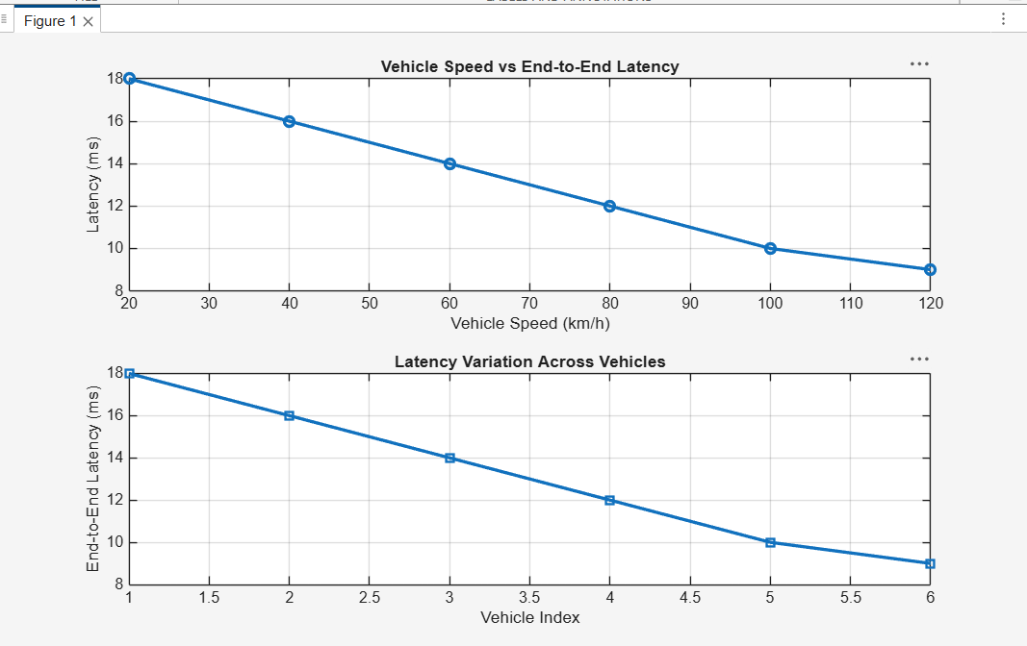
2. To analyze the Packet Delivery Ratio (%) and determine the reliability of V2X
communication during data transmission.
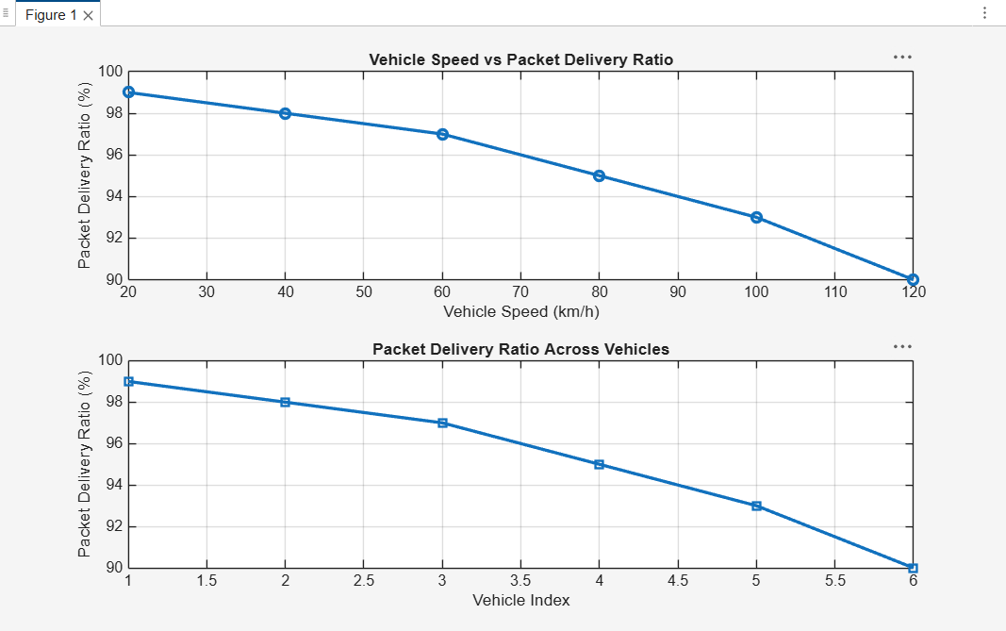
- To study the impact of Vehicle Speed (km/h) on the communication performance and stability of the V2X network.
